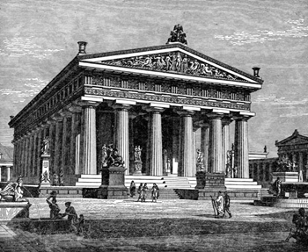
THE GREEKS
As citizens of the United States of America, we owe everything to ancient Greece. Many of the ideals we so highly cherish aren't American; they're Greek. It was in ancient Athens that the citizens stood up and declared that they would no longer be ruled by kings. The people should rule. Americans didn't invent democracy; Greeks did.
The art of storytelling was perfected in ancient Greece. The colorful myths and legends of the land gave the poet Homer plenty to work with. For the first time the plot took a back seat to characterization, language, and presentation. Literature was born in ancient Greece. Theater got its start there, too. The Greeks were the first to stage complex plays that commented on current events. Aeschylus, Sophocles, and Euripides pushed the boundaries of drama and showed the world that the pen can be mightier than the sword.
As for the Greek philosophers, Socrates, Plato, and Aristotle redefined the way that human beings thought about the universe. Hippocrates founded a school dedicated to the scientific study of the body. Mathematicians such as Pythagoras developed new theories. Herodotus developed a factual approach for recording past events called history. Meanwhile, Aesop wrote his moral-driven fables, and the politician Pericles demonstrated how one man can shape a city.
While all these breakthroughs were happening in Athens, the Greeks in Sparta were working on another development: the art of war. Discipline, strategy, honor were all taken to the extreme in the militaristic environment of Sparta. While the Athenians showed Greece how to think, Sparta showed Greece how to fight.

